SC Server and Database Queries Overview

- SC Servers:

10.4.1.31 - Database (DB) Server
DB Name: VMWSC.Digital DB
DB user: SA
DB password: P#ssw-rd098.

10.4.1.29 - SC Application Server 1:
Server username: administrator
Server password: P#ssw-rd098
Physical Path: C:\Leading-Point\SCAPI.Digital.

10.4.1.23 - SC Application Server 2:
Server username: administrator
Server password: P#ssw-rd098
Physical Path: C:\Leading-Point\SCAPI.Digital.

- The API on SC:
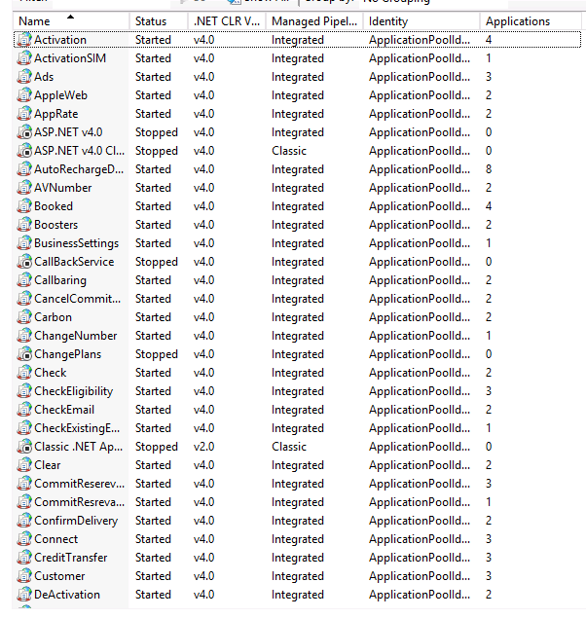
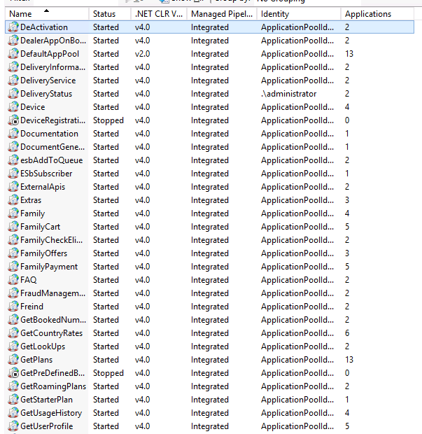

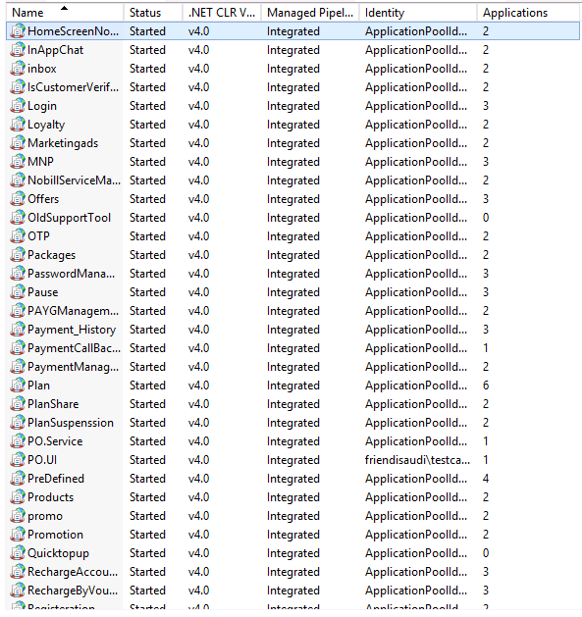
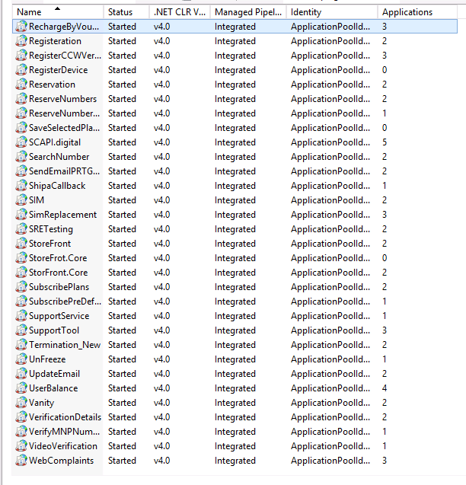

- SC Database Queries and Their Purpose

1. Check Booked Numbers Status:

Select * from booked_numbers where bookednumber = '' order by 1 desc
Select * from booked_numbers where regid = '' order by 1 desc
Select * from booked_numbers where email = '' order by 1 desc

Purpose: These queries retrieve information about the status of booked numbers.
Key Status:

ReservationStatus = 1: The customer reserved the number but has not paid.
ReservationStatus = 3: The customer has reserved and paid for the number.
If BookingStatus = 1: The customer activated the number.
If BookingStatus = 0: The customer has paid but the number is still not active.
ReservationStatus=4:The customer cancel the reservation.
ReservationStatus=5:The auto cancel cancel the reservation based on expiry date.

2. Check Customer Registration Status

Select * from Registration where email = '' order by 1 desc
Select * from Registration where id = '' order by 1 desc

Purpose: To verify if a customer’s account is active and retrieve their information, including the customer ID.

3. Check User Plan

Select * from UserSelectedPlan where regid = '' order by 1 desc
Select * from UserSelectedPlan where bookednumberid = '' order by 1 desc

Purpose: To verify the user’s selected plan and ensure it is correctly linked to the payment ID and booked number ID.

4. Check Payment Status
Select * from Servicepayment where regid = '' order by 1 desc
Select * from Servicepayment where id = ''
Select * from Servicepayment where MSISDN = '' order by 1 desc

Purpose: To check the payment status of a customer, including whether the payment is confirmed.

5. Check Customer API Log

Select * from MethodTrace with (nolock) where regid = '' order by 1 desc

Purpose: To review the log of APIs the customer has called from the app. This helps in diagnosing issues with the API, tracking responses, and monitoring processing times.

6. Check API Exceptions

Select * from Log with (nolock) where regid = '' order by 1 desc

Purpose: To identify any exceptions encountered by the API for a specific customer or general API-related exceptions.

